Table of Contents

1 Named sets Error: Reference source not found
1.1 Default view of whole model Error: Reference source not found
1.1.1 All : None Error: Reference source not found
1.1.1.1 All_None_None Error: Reference source not found
1.2 Default view of named sets Error: Reference source not found
1.2.1 Lower_deck : None Error: Reference source not found
1.2.1.1 Lower_deck_None_None Error: Reference source not found
1.2.2 Upper_deck : None Error: Reference source not found
1.2.2.1 Upper_deck_None_None Error: Reference source not found
1.3 Material view of named sets Error: Reference source not found
1.3.1 Lower_deck : Material Error: Reference source not found
1.3.1.1 Lower_deck_Material_None Error: Reference source not found
1.3.2 Upper_deck : Material Error: Reference source not found
1.3.2.1 Upper_deck_Material_None Error: Reference source not found
1.4 Section view of named sets Error: Reference source not found
1.4.1 Lower_deck : Section Error: Reference source not found
1.4.1.1 Lower_deck_Section_None Error: Reference source not found
1.4.2 Upper_deck : Section Error: Reference source not found
1.4.2.1 Upper_deck_Section_None Error: Reference source not found
1.5 Thickness view of named sets Error: Reference source not found
1.5.1 Lower_deck : Thickness Error: Reference source not found
1.5.1.1 Lower_deck_Thickness_None Error: Reference source not found
1.5.2 Upper_deck : Thickness Error: Reference source not found
1.5.2.1 Upper_deck_Thickness_None Error: Reference source not found
1.6 Mesh view with thickness of named sets Error: Reference source not found
1.6.1 Lower_deck : Thickness Error: Reference source not found
1.6.1.1 Lower_deck_Mesh_None_Thickness Error: Reference source not found
1.6.2 Upper_deck : Thickness Error: Reference source not found
1.6.2.1 Upper_deck_Mesh_None_Thickness Error: Reference source not found
1.7 Loads and results for loadcase : Combo Error: Reference source not found
1.7.1 All : None Error: Reference source not found
1.7.1.1 All_None_Combo Error: Reference source not found
1.7.2 All : None Error: Reference source not found
1.7.2.1 All_Mesh_Combo_None Error: Reference source not found
1.7.3 All : Combo Error: Reference source not found
1.7.3.1 All_Results_Combo_VonMises Error: Reference source not found
1.8 Loads and results for loadcase : Equipments_L_deck Error: Reference source not found
1.8.1 All : None Error: Reference source not found
1.8.1.1 All_None_Equipments_L_deck Error: Reference source not found
1.8.2 All : None Error: Reference source not found
1.8.2.1 All_Mesh_Equipments_L_deck_None Error: Reference source not found
1.8.3 All : Equipments_L_deck Error: Reference source not found
1.8.3.1 All_Results_Equipments_L_deck_VonMises Error: Reference source not found
1.9 Loads and results for loadcase : Equipments_U_deck Error: Reference source not found
1.9.1 All : None Error: Reference source not found
1.9.1.1 All_None_Equipments_U_deck Error: Reference source not found
1.9.2 All : None Error: Reference source not found
1.9.2.1 All_Mesh_Equipments_U_deck_None Error: Reference source not found
1.9.3 All : Equipments_U_deck Error: Reference source not found
1.9.3.1 All_Results_Equipments_U_deck_VonMises Error: Reference source not found
1.10 Loads and results for loadcase : Selfweight Error: Reference source not found
1.10.1 All : None Error: Reference source not found
1.10.1.1 All_None_Selfweight Error: Reference source not found
1.10.2 All : None Error: Reference source not found
1.10.2.1 All_Mesh_Selfweight_None Error: Reference source not found
1.10.3 All : Selfweight Error: Reference source not found
1.10.3.1 All_Results_Selfweight_VonMises Error: Reference source not found
1.11 Loads and results for loadcase : Upper_pressure Error: Reference source not found
1.11.1 All : None Error: Reference source not found
1.11.1.1 All_None_Upper_pressure Error: Reference source not found
1.11.2 All : None Error: Reference source not found
1.11.2.1 All_Mesh_Upper_pressure_None Error: Reference source not found
1.11.3 All : Upper_pressure Error: Reference source not found
1.11.3.1 All_Results_Upper_pressure_VonMises Error: Reference source not found
1.12 Loads and results for loadcase : X_acceleration Error: Reference source not found
1.12.1 All : None Error: Reference source not found
1.12.1.1 All_None_X_acceleration Error: Reference source not found
1.12.2 All : None Error: Reference source not found
1.12.2.1 All_Mesh_X_acceleration_None Error: Reference source not found
1.12.3 All : X_acceleration Error: Reference source not found
1.12.3.1 All_Results_X_acceleration_VonMises Error: Reference source not found
1.13 Capacity check results of named sets for worst loadcase Error: Reference source not found
1.13.1 Lower_deck : UfTot Error: Reference source not found
1.13.1.1 Lower_deck_Results_UfTot_Worst Error: Reference source not found
1.13.2 Upper_deck : UfTot Error: Reference source not found
1.13.2.1 Upper_deck_Results_UfTot_Worst Error: Reference source not found

1 Named sets

1.1 Default view of whole model

1.1.1 All : None

1.1.1.1 All_None_None

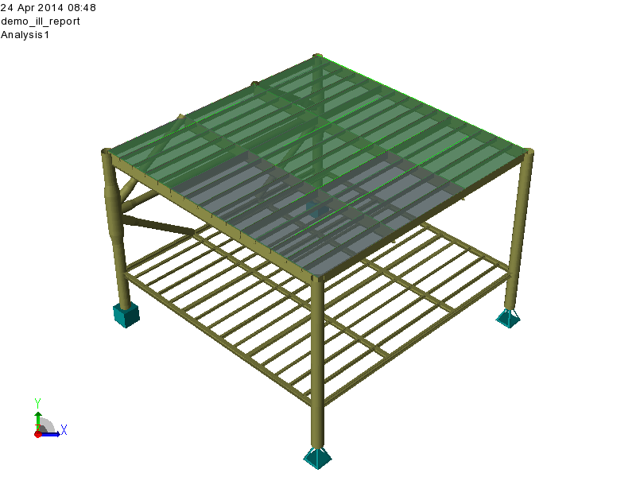

All_None_None.png : All_None_None

1.2 Default view of named sets

1.2.1 Lower_deck : None

1.2.1.1 Lower_deck_None_None

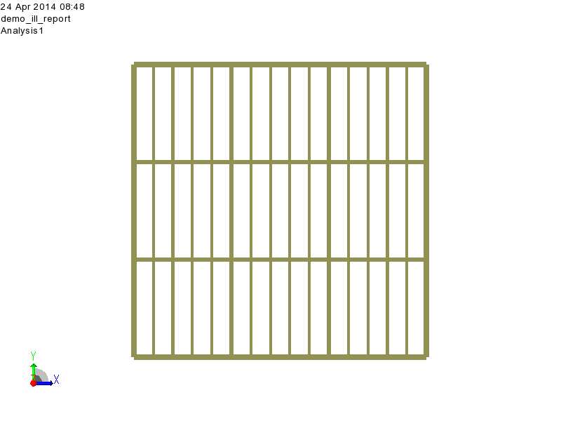

Lower_deck_None_None.png : Lower_deck_None_None

1.2.2 Upper_deck : None

1.2.2.1 Upper_deck_None_None

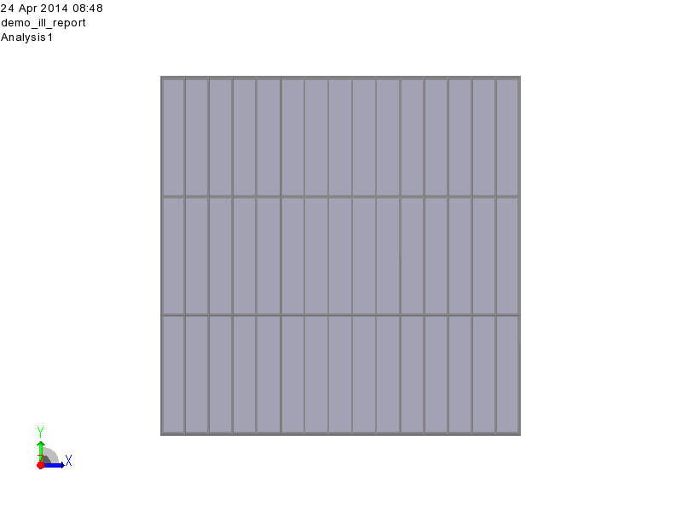

Upper_deck_None_None.png : Upper_deck_None_None

1.3 Material view of named sets

1.3.1 Lower_deck : Material

1.3.1.1 Lower_deck_Material_None

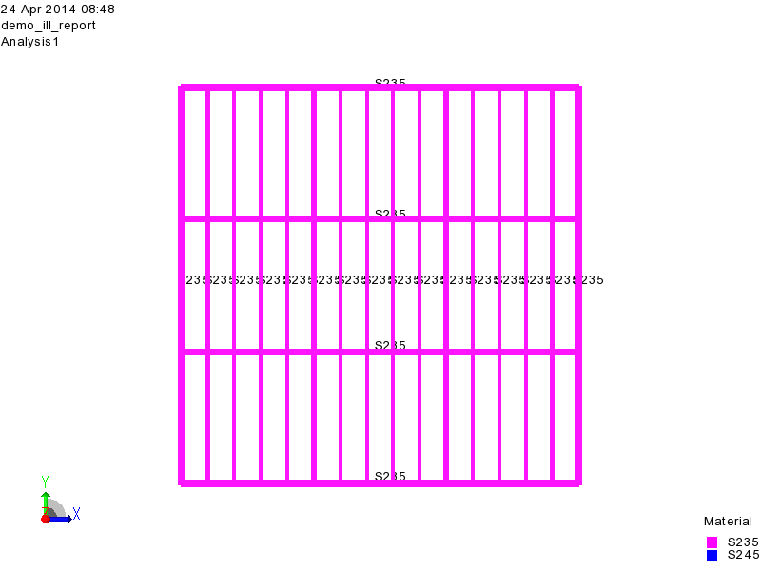

Lower_deck_Material_None.png : Lower_deck_Material_None

1.3.2 Upper_deck : Material

1.3.2.1 Upper_deck_Material_None

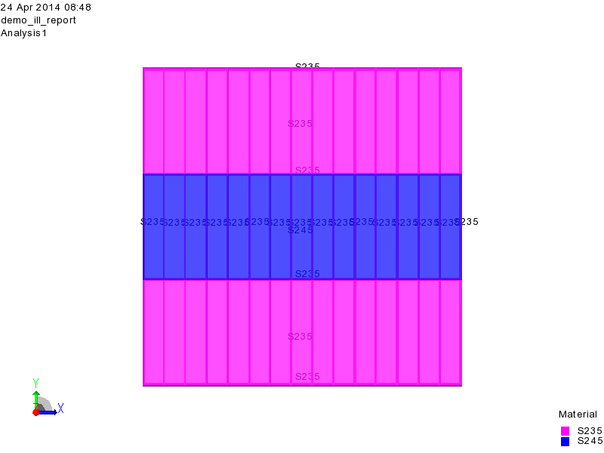

Upper_deck_Material_None.png : Upper_deck_Material_None

1.4 Section view of named sets

1.4.1 Lower_deck : Section

1.4.1.1 Lower_deck_Section_None

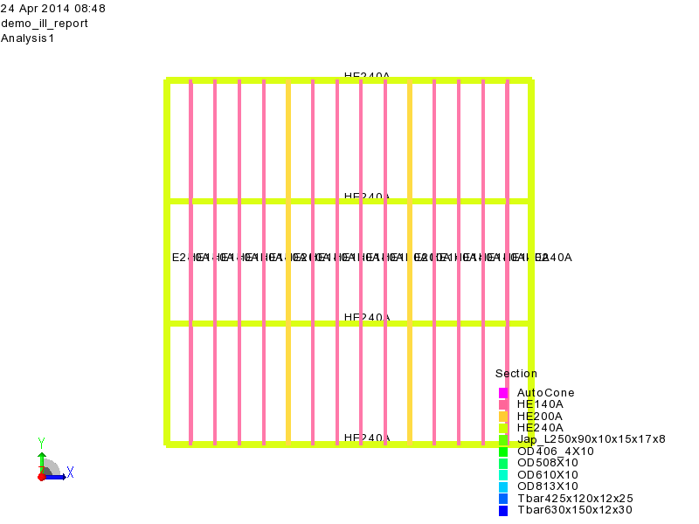

Lower_deck_Section_None.png : Lower_deck_Section_None

1.4.2 Upper_deck : Section

1.4.2.1 Upper_deck_Section_None

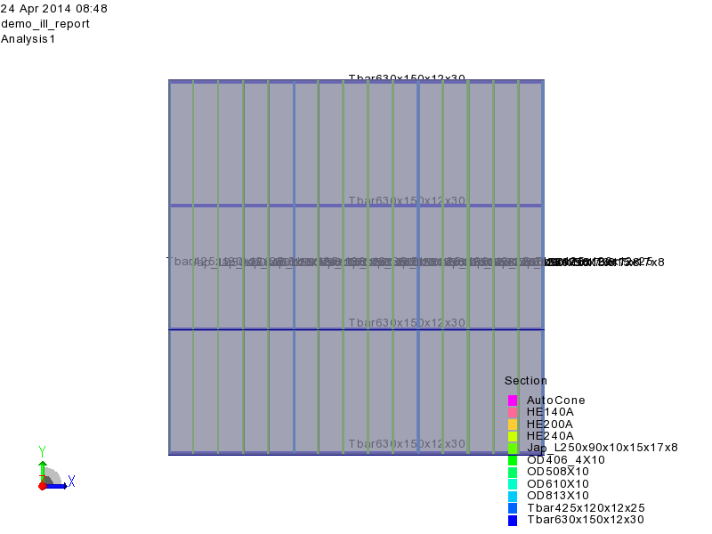

Upper_deck_Section_None.png : Upper_deck_Section_None

1.5 Thickness view of named sets

1.5.1 Lower_deck : Thickness

1.5.1.1 Lower_deck_Thickness_None

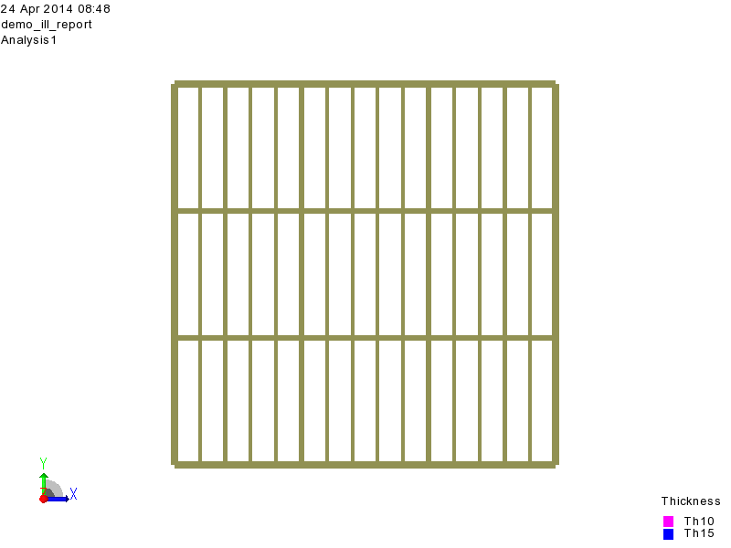

Lower_deck_Thickness_None.png : Lower_deck_Thickness_None

1.5.2 Upper_deck : Thickness

1.5.2.1 Upper_deck_Thickness_None

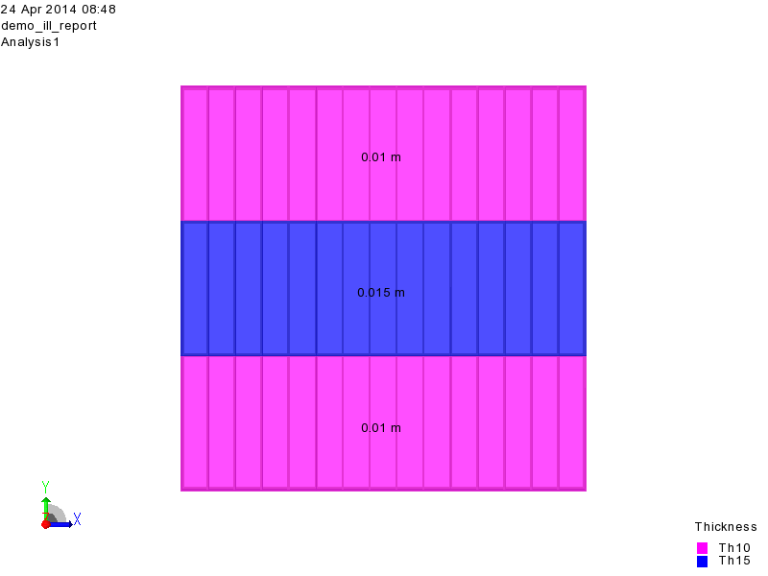

Upper_deck_Thickness_None.png : Upper_deck_Thickness_None

1.6 Mesh view with thickness of named sets

1.6.1 Lower_deck : Thickness

1.6.1.1 Lower_deck_Mesh_None_Thickness

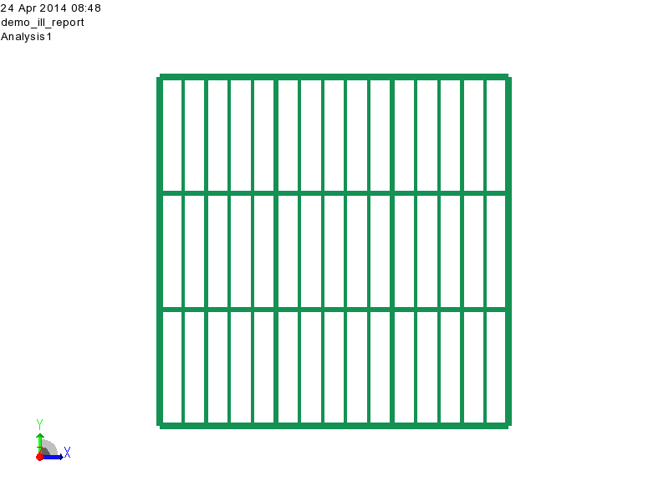

Lower_deck_Mesh_None_Thickness.png : Lower_deck_Mesh_None_Thickness

1.6.2 Upper_deck : Thickness

1.6.2.1 Upper_deck_Mesh_None_Thickness

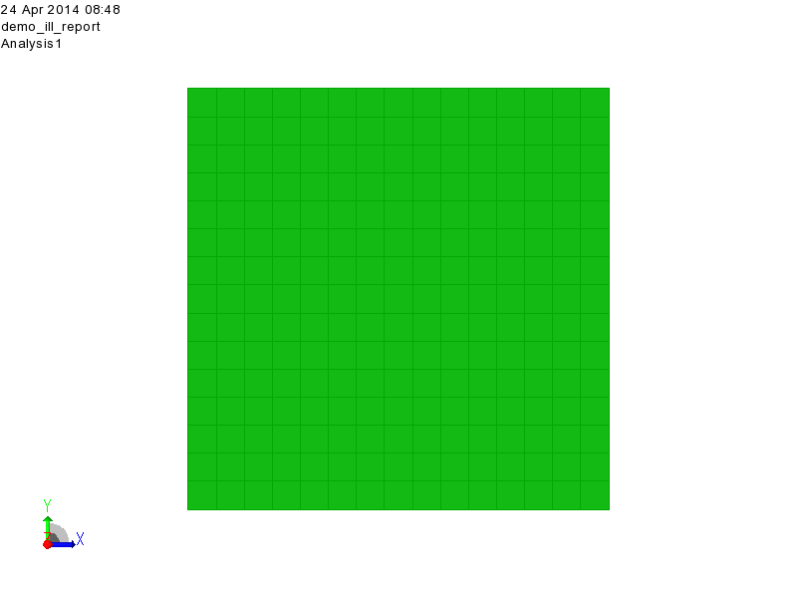

Upper_deck_Mesh_None_Thickness.png : Upper_deck_Mesh_None_Thickness

1.7 Loads and results for loadcase : Combo

1.7.1 All : None

1.7.1.1 All_None_Combo

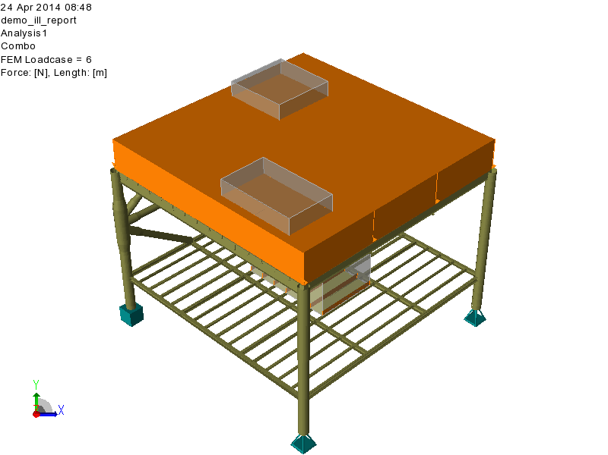

All_None_Combo.png : All_None_Combo

1.7.2 All : None

1.7.2.1 All_Mesh_Combo_None

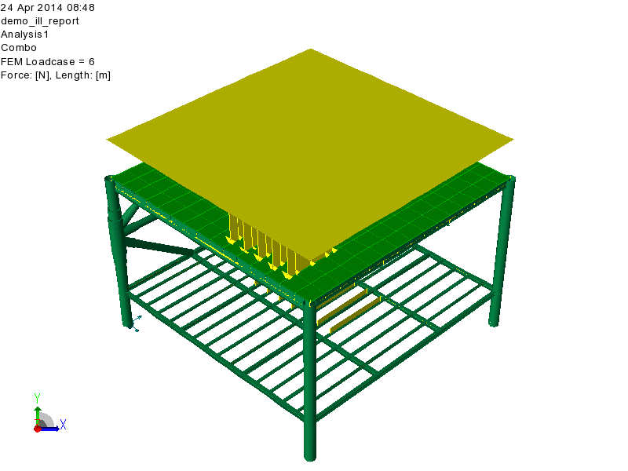

All_Mesh_Combo_None.png : All_Mesh_Combo_None

1.7.3 All : Combo

1.7.3.1 All_Results_Combo_VonMises

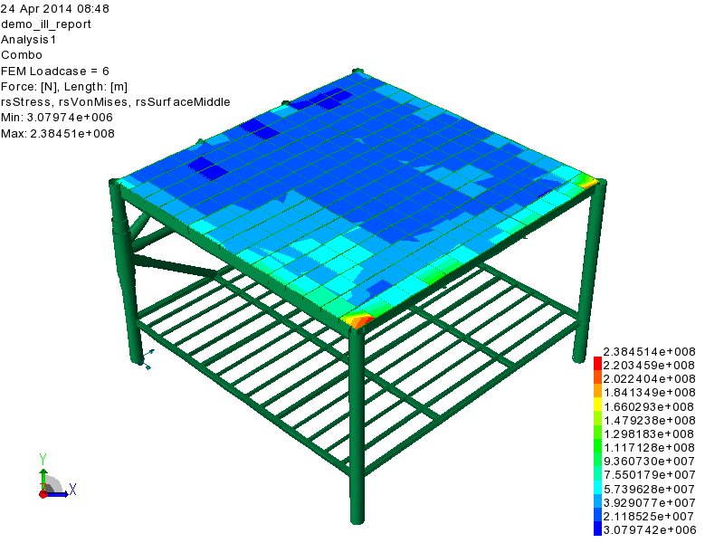

All_Results_Combo_VonMises.png : All_Results_Combo_VonMises

1.8 Loads and results for loadcase : Equipments_L_deck

1.8.1 All : None

1.8.1.1 All_None_Equipments_L_deck

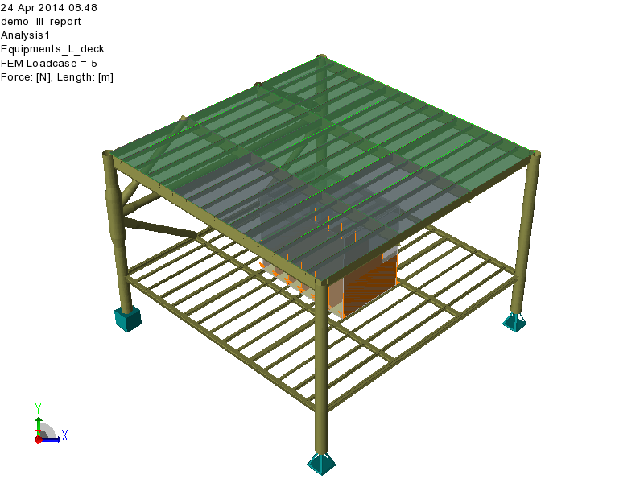

All_None_Equipments_L_deck.png : All_None_Equipments_L_deck

1.8.2 All : None

1.8.2.1 All_Mesh_Equipments_L_deck_None

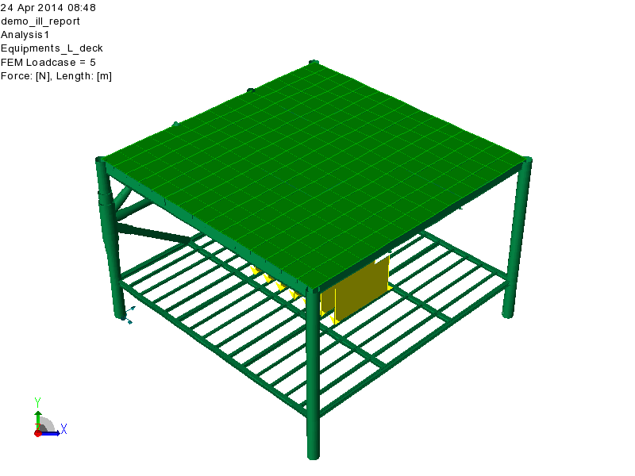

All_Mesh_Equipments_L_deck_None.png : All_Mesh_Equipments_L_deck_None

1.8.3 All : Equipments_L_deck

1.8.3.1 All_Results_Equipments_L_deck_VonMises

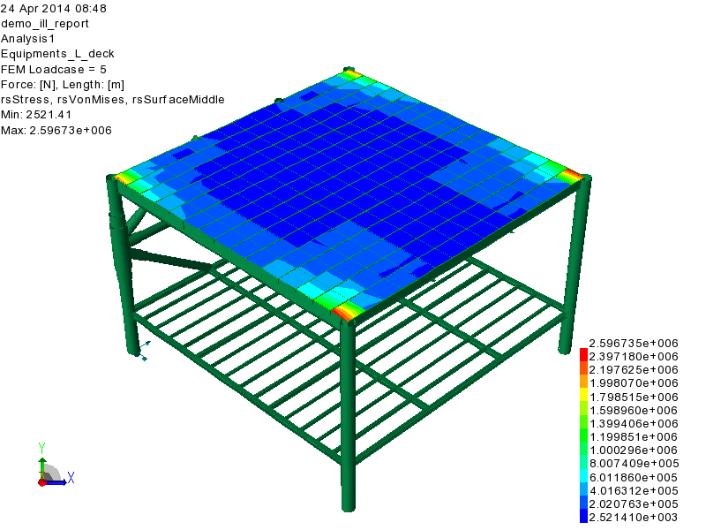

All_Results_Equipments_L_deck_VonMises.png : All_Results_Equipments_L_deck_VonMises

1.9 Loads and results for loadcase : Equipments_U_deck

1.9.1 All : None

1.9.1.1 All_None_Equipments_U_deck

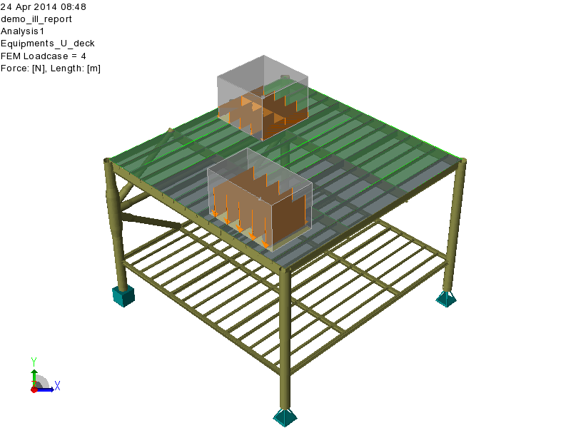

All_None_Equipments_U_deck.png : All_None_Equipments_U_deck

1.9.2 All : None

1.9.2.1 All_Mesh_Equipments_U_deck_None

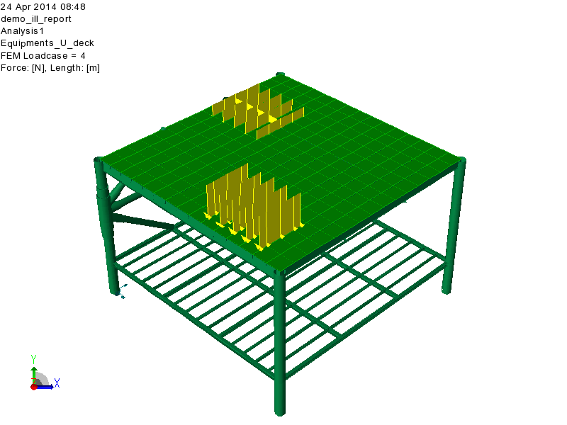

All_Mesh_Equipments_U_deck_None.png : All_Mesh_Equipments_U_deck_None

1.9.3 All : Equipments_U_deck

1.9.3.1 All_Results_Equipments_U_deck_VonMises

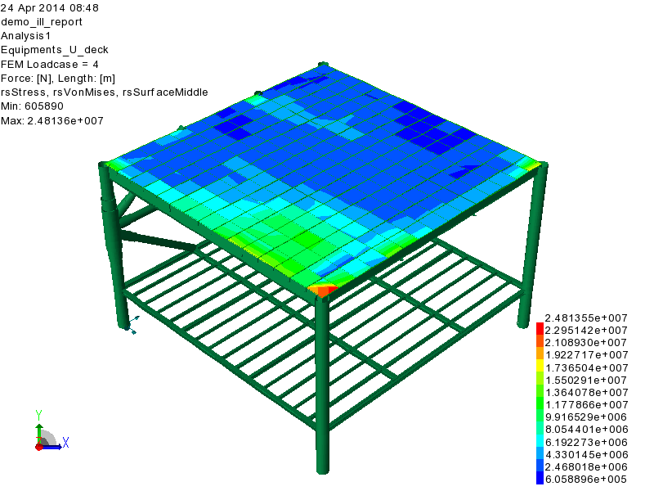

All_Results_Equipments_U_deck_VonMises.png : All_Results_Equipments_U_deck_VonMises

1.10 Loads and results for loadcase : Selfweight

1.10.1 All : None

1.10.1.1 All_None_Selfweight

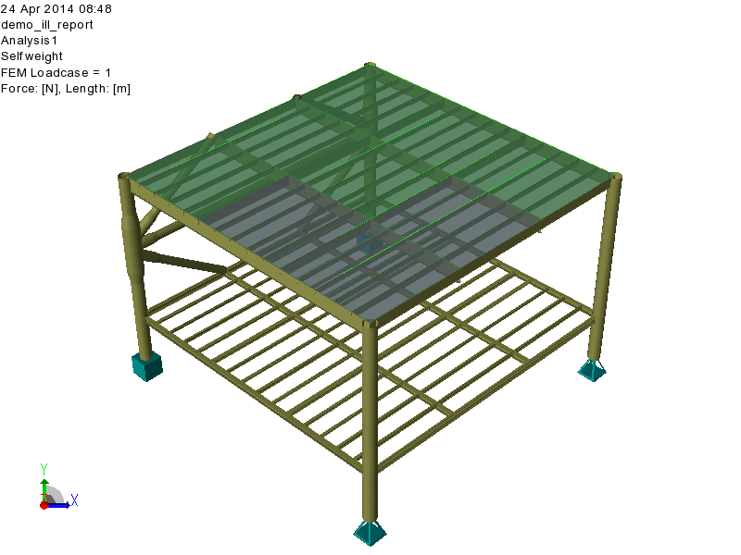

All_None_Selfweight.png : All_None_Selfweight

1.10.2 All : None

1.10.2.1 All_Mesh_Selfweight_None

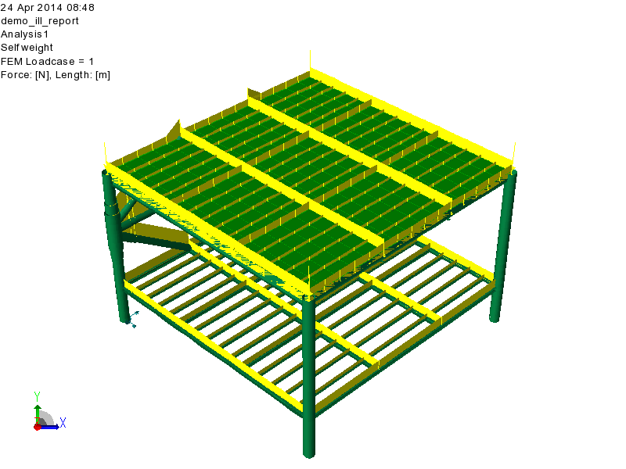

All_Mesh_Selfweight_None.png : All_Mesh_Selfweight_None

1.10.3 All : Selfweight

1.10.3.1 All_Results_Selfweight_VonMises

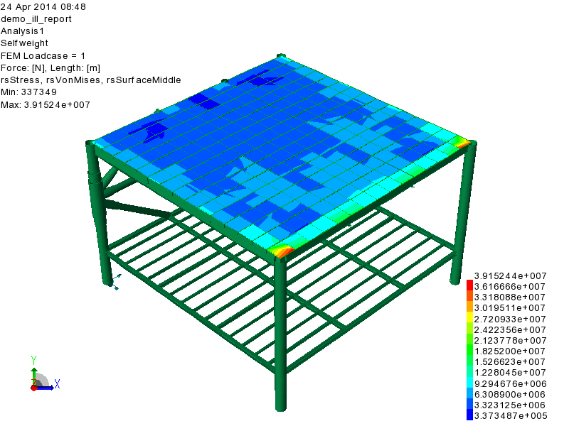

All_Results_Selfweight_VonMises.png : All_Results_Selfweight_VonMises

1.11 Loads and results for loadcase : Upper_pressure

1.11.1 All : None

1.11.1.1 All_None_Upper_pressure

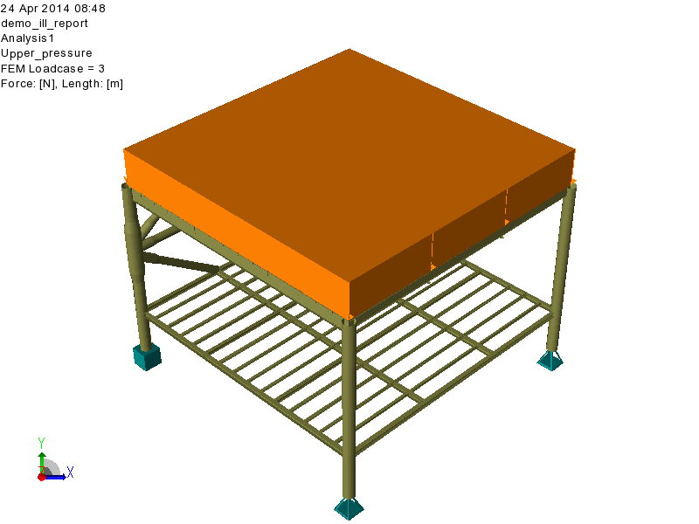

All_None_Upper_pressure.png : All_None_Upper_pressure

1.11.2 All : None

1.11.2.1 All_Mesh_Upper_pressure_None

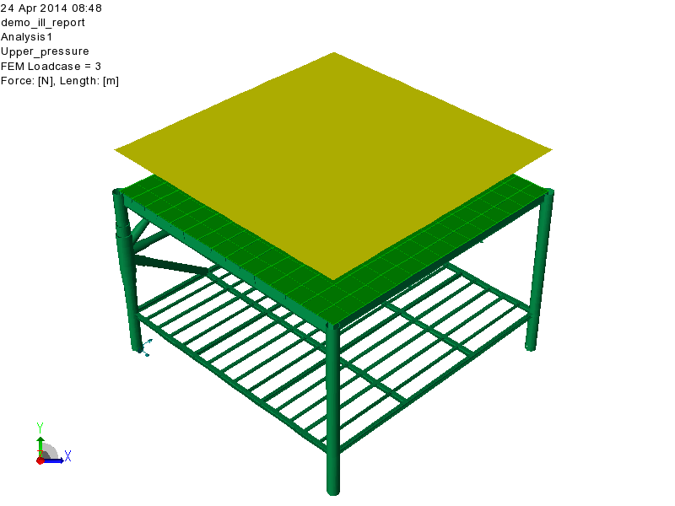

All_Mesh_Upper_pressure_None.png : All_Mesh_Upper_pressure_None

1.11.3 All : Upper_pressure

1.11.3.1 All_Results_Upper_pressure_VonMises

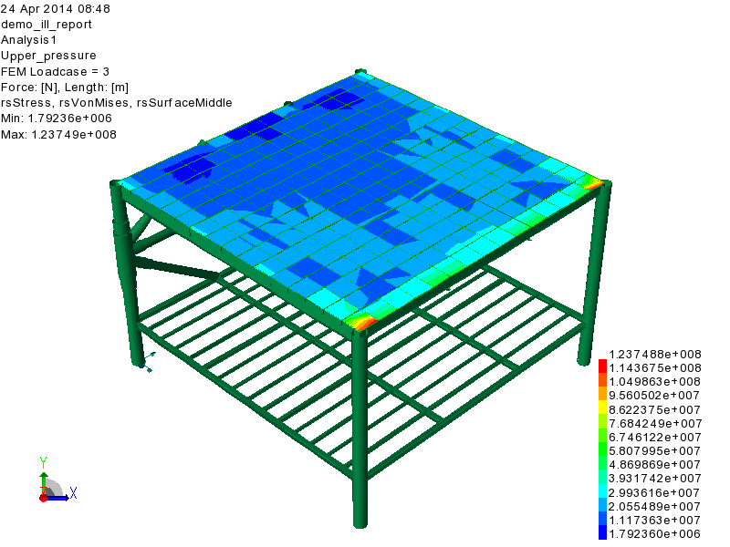

All_Results_Upper_pressure_VonMises.png : All_Results_Upper_pressure_VonMises

1.12 Loads and results for loadcase : X_acceleration

1.12.1 All : None

1.12.1.1 All_None_X_acceleration

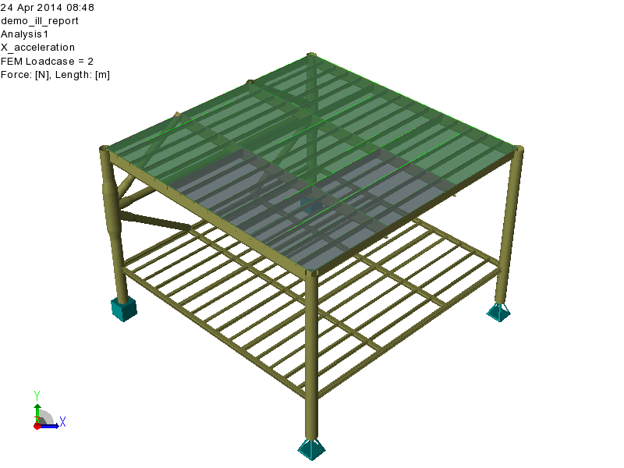

All_None_X_acceleration.png : All_None_X_acceleration

1.12.2 All : None

1.12.2.1 All_Mesh_X_acceleration_None

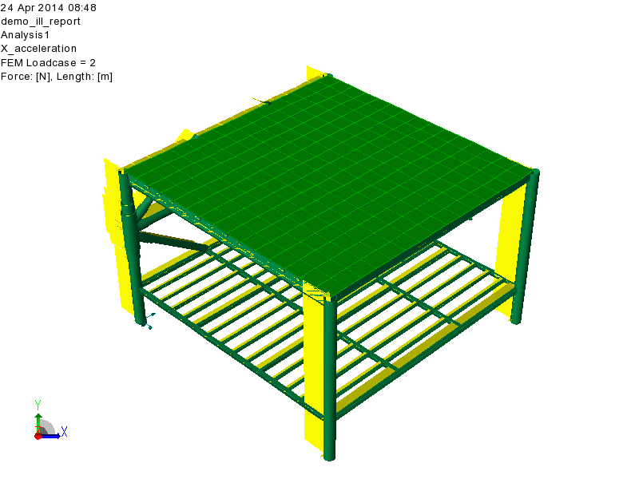

All_Mesh_X_acceleration_None.png : All_Mesh_X_acceleration_None

1.12.3 All : X_acceleration

1.12.3.1 All_Results_X_acceleration_VonMises

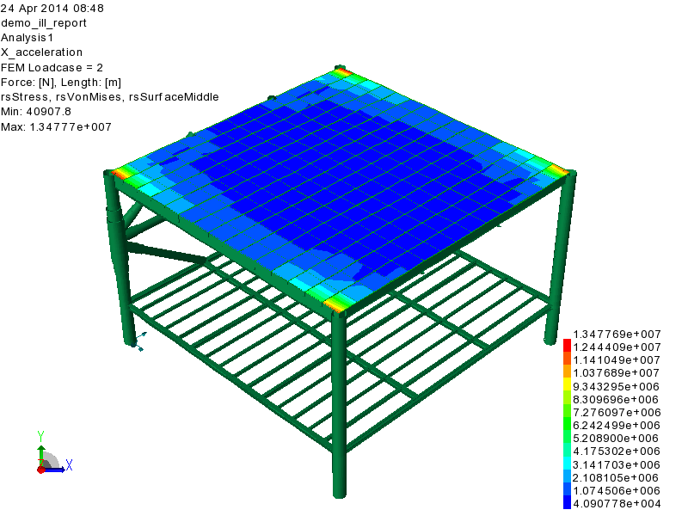

All_Results_X_acceleration_VonMises.png : All_Results_X_acceleration_VonMises

1.13 Capacity check results of named sets for worst loadcase

1.13.1 Lower_deck : UfTot

1.13.1.1 Lower_deck_Results_UfTot_Worst

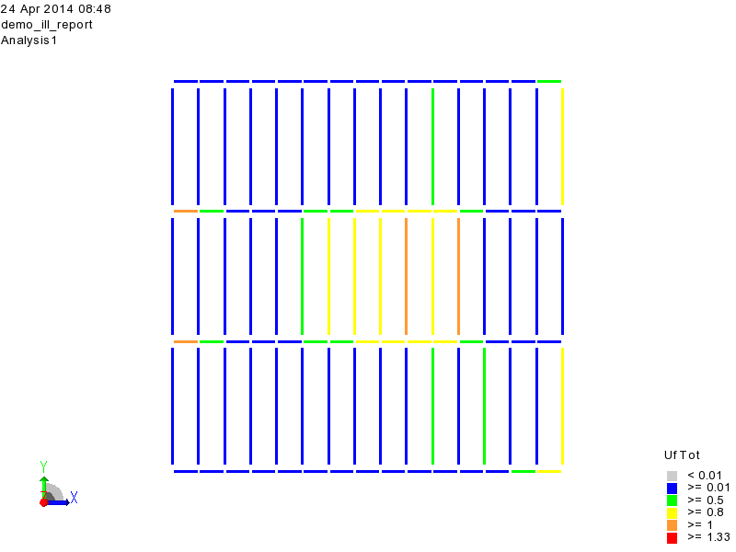

Lower_deck_Results_UfTot_Worst.png : Lower_deck_Results_UfTot_Worst

1.13.2 Upper_deck : UfTot

1.13.2.1 Upper_deck_Results_UfTot_Worst

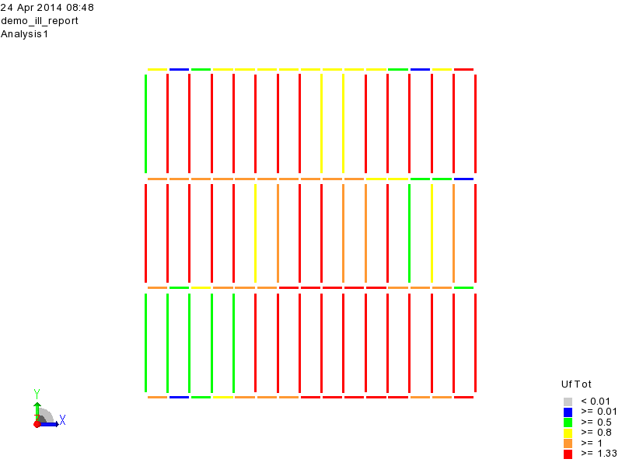

Upper_deck_Results_UfTot_Worst.png : Upper_deck_Results_UfTot_Worst

