Table of Contents

1 Structural model Error: Reference source not found
1.1 Pictures Error: Reference source not found
1.1.1 ModelView1 Error: Reference source not found
1.1.1.1 ModelView1_Modelling - All Error: Reference source not found
1.1.1.2 ModelView1_Modelling - Transparent Error: Reference source not found
1.1.1.3 ModelView1_Mesh - View Error: Reference source not found
1.1.2 ModelView2 Error: Reference source not found
1.1.2.1 ModelView2_Modelling - All Error: Reference source not found
1.1.2.2 ModelView2_Modelling - Transparent Error: Reference source not found
1.1.2.3 ModelView2_Mesh - View Error: Reference source not found
1.1.3 ModelView3 Error: Reference source not found
1.1.3.1 ModelView3_Modelling - All Error: Reference source not found
1.1.3.2 ModelView3_Modelling - Transparent Error: Reference source not found
1.1.3.3 ModelView3_Mesh - View Error: Reference source not found
1.1.4 ModelView4 Error: Reference source not found
1.1.4.1 ModelView4_Modelling - All Error: Reference source not found
1.1.4.2 ModelView4_Modelling - Transparent Error: Reference source not found
1.1.4.3 ModelView4_Mesh - View Error: Reference source not found

1 Structural model

1.1 Pictures

1.1.1 ModelView1

1.1.1.1 ModelView1_Modelling - All

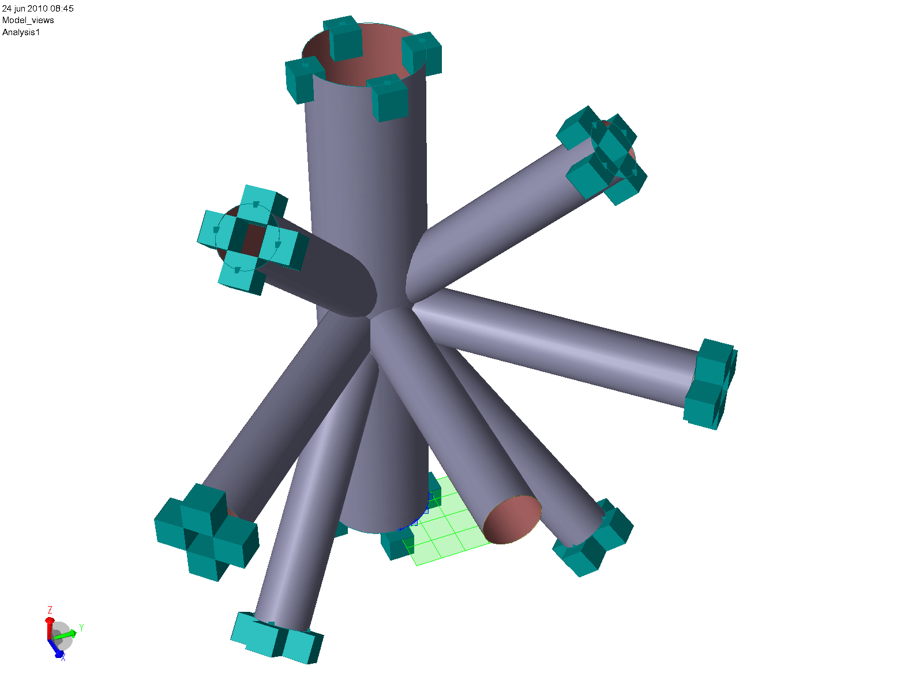

ModelView1_Modelling - All.png : ModelView1_Modelling - All

1.1.1.2 ModelView1_Modelling - Transparent

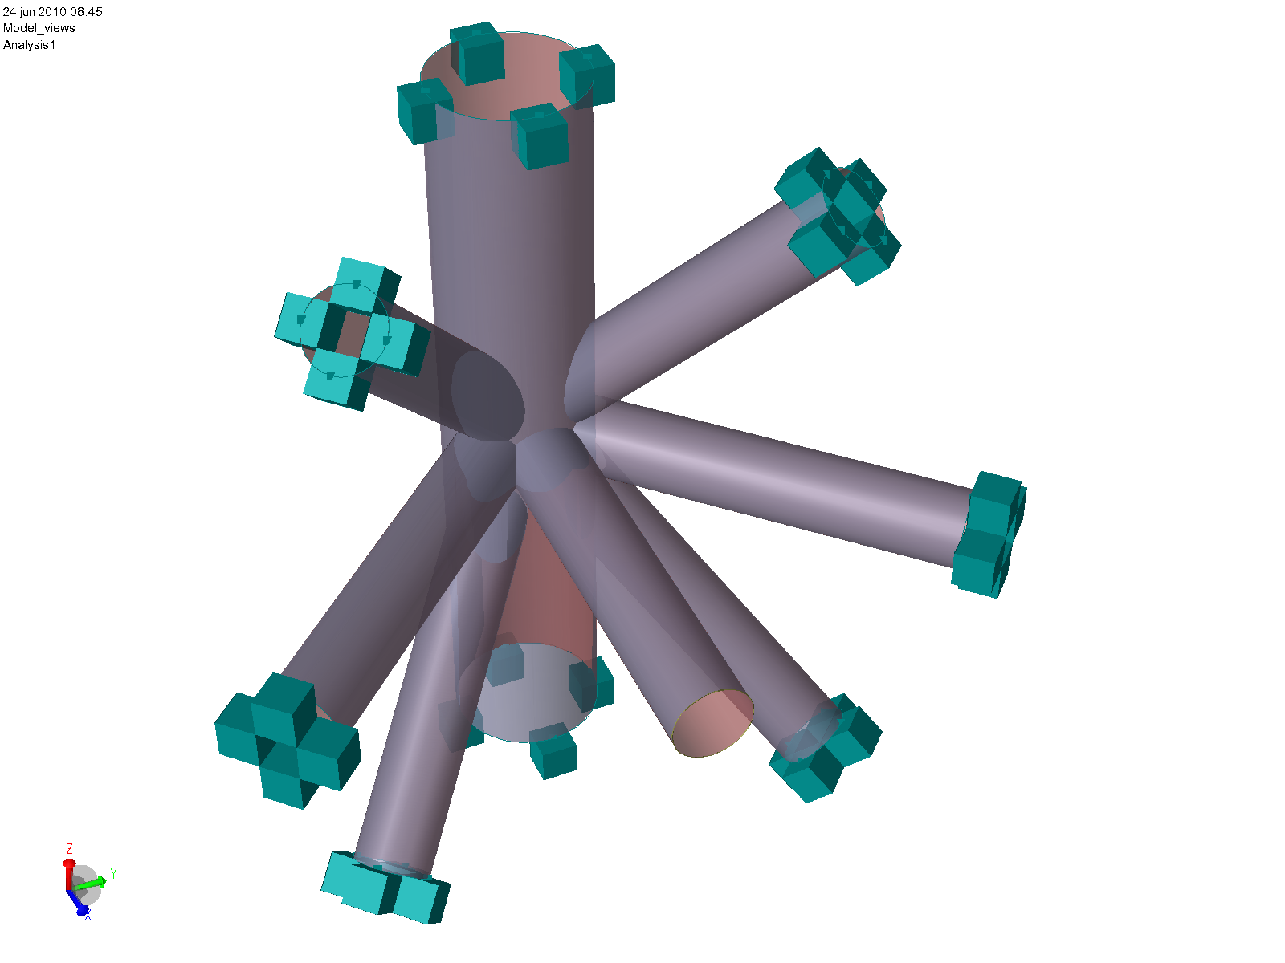

ModelView1_Modelling - Transparent.png : ModelView1_Modelling - Transparent

1.1.1.3 ModelView1_Mesh - View

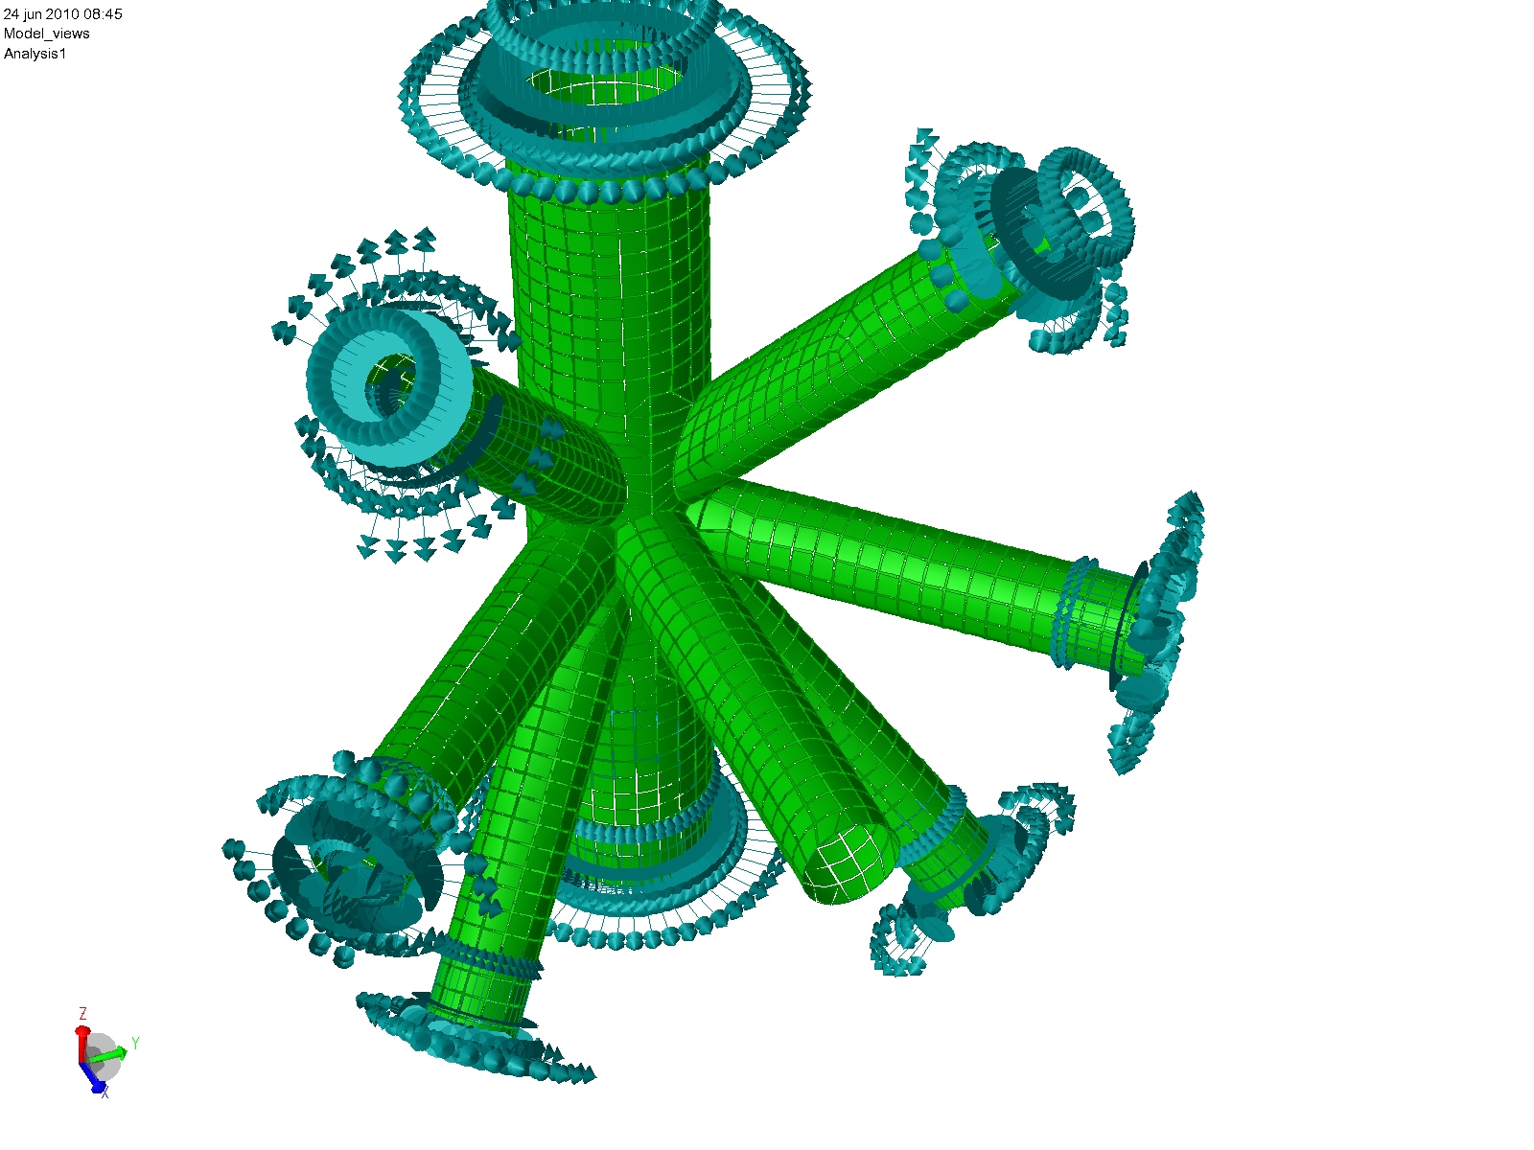

ModelView1_Mesh - View.png : ModelView1_Mesh - View

1.1.2 ModelView2

1.1.2.1 ModelView2_Modelling - All

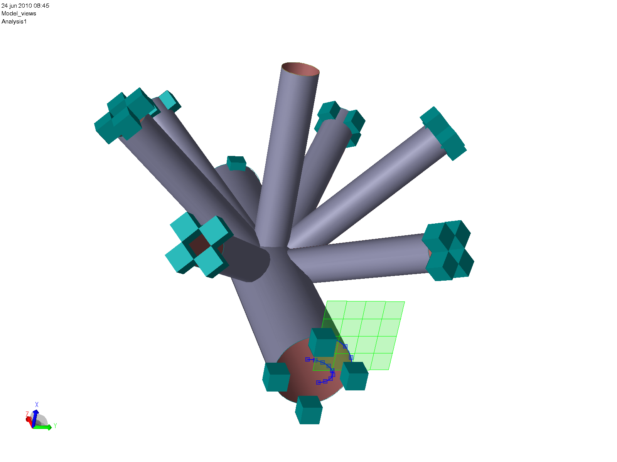

ModelView2_Modelling - All.png : ModelView2_Modelling - All

1.1.2.2 ModelView2_Modelling - Transparent

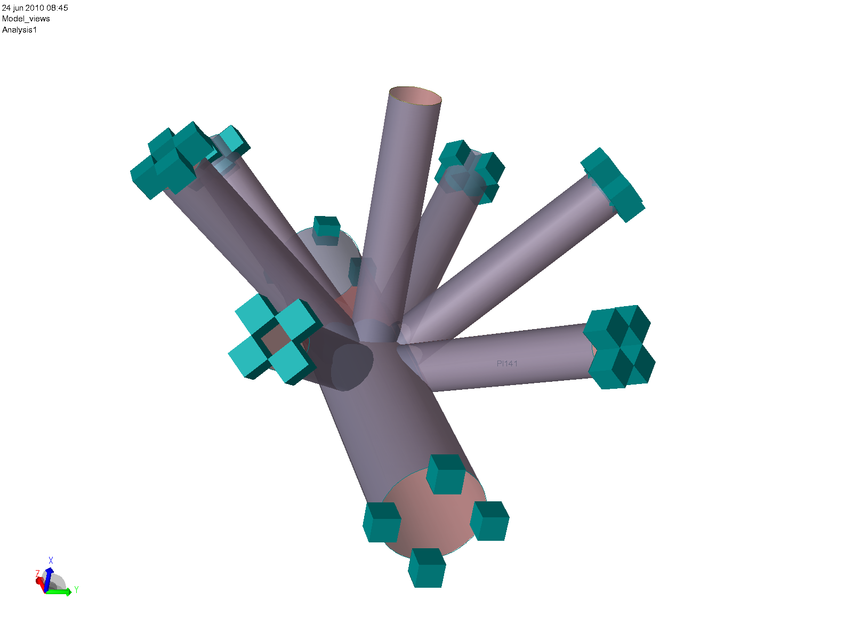

ModelView2_Modelling - Transparent.png : ModelView2_Modelling - Transparent

1.1.2.3 ModelView2_Mesh - View

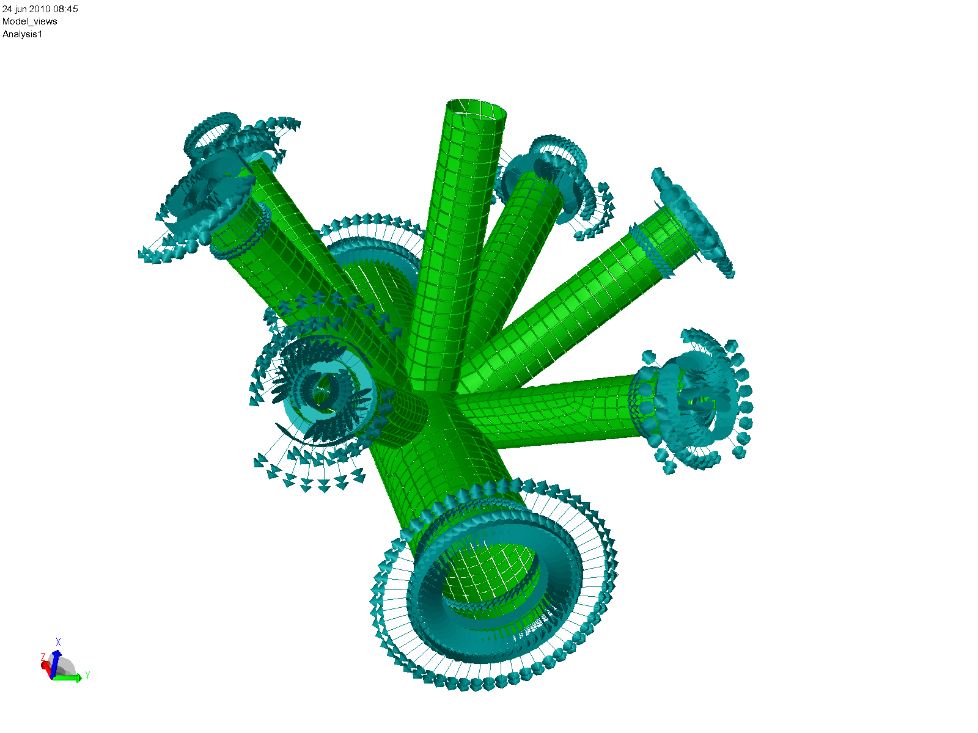

ModelView2_Mesh - View.png : ModelView2_Mesh - View

1.1.3 ModelView3

1.1.3.1 ModelView3_Modelling - All

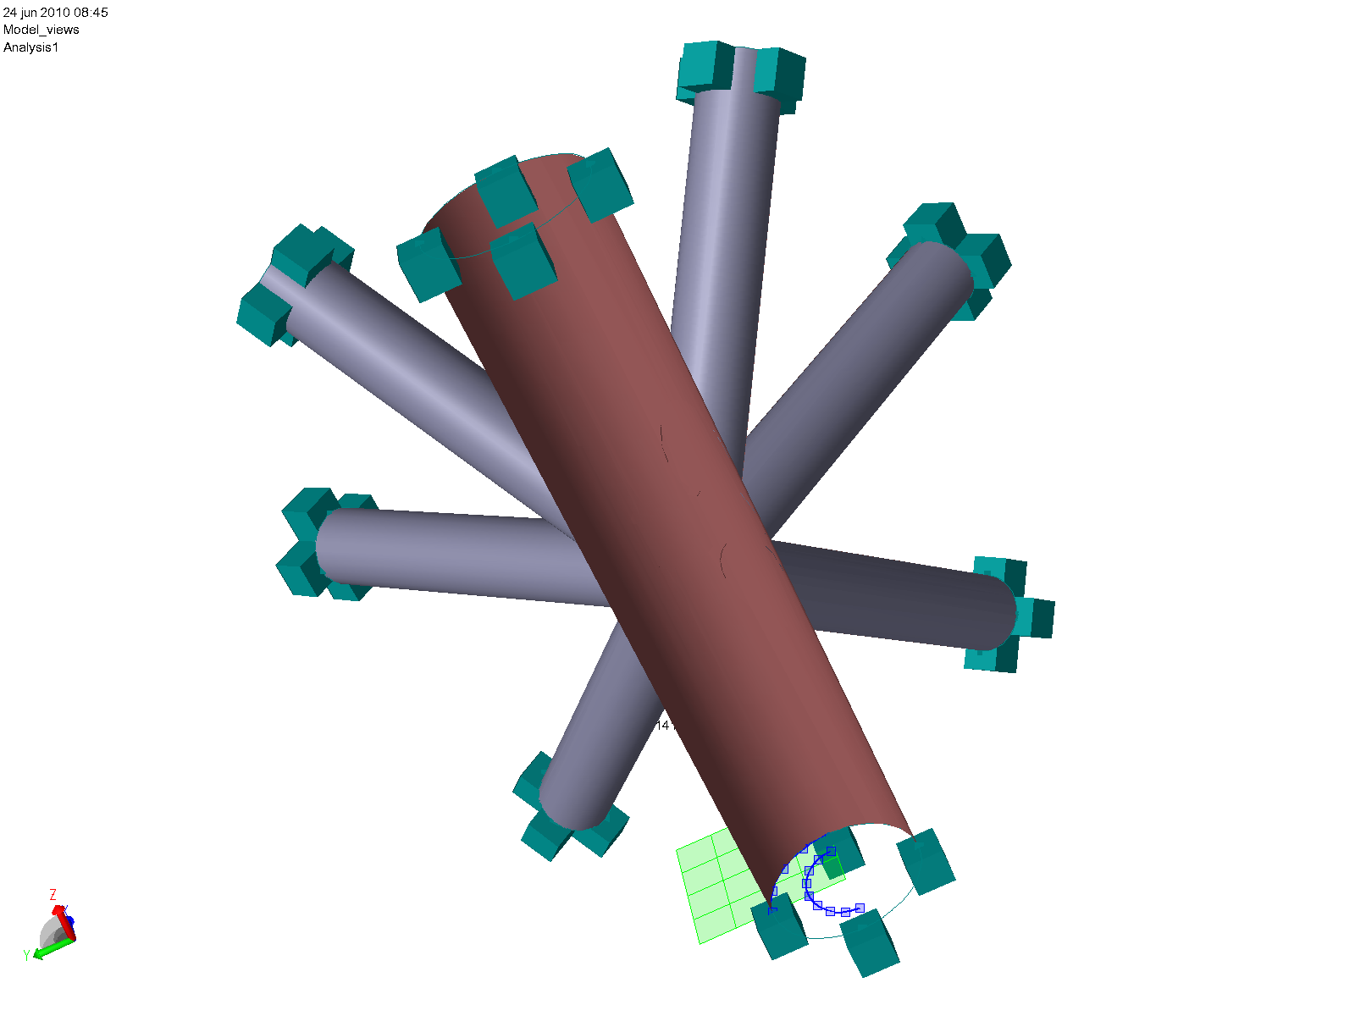

ModelView3_Modelling - All.png : ModelView3_Modelling - All

1.1.3.2 ModelView3_Modelling - Transparent

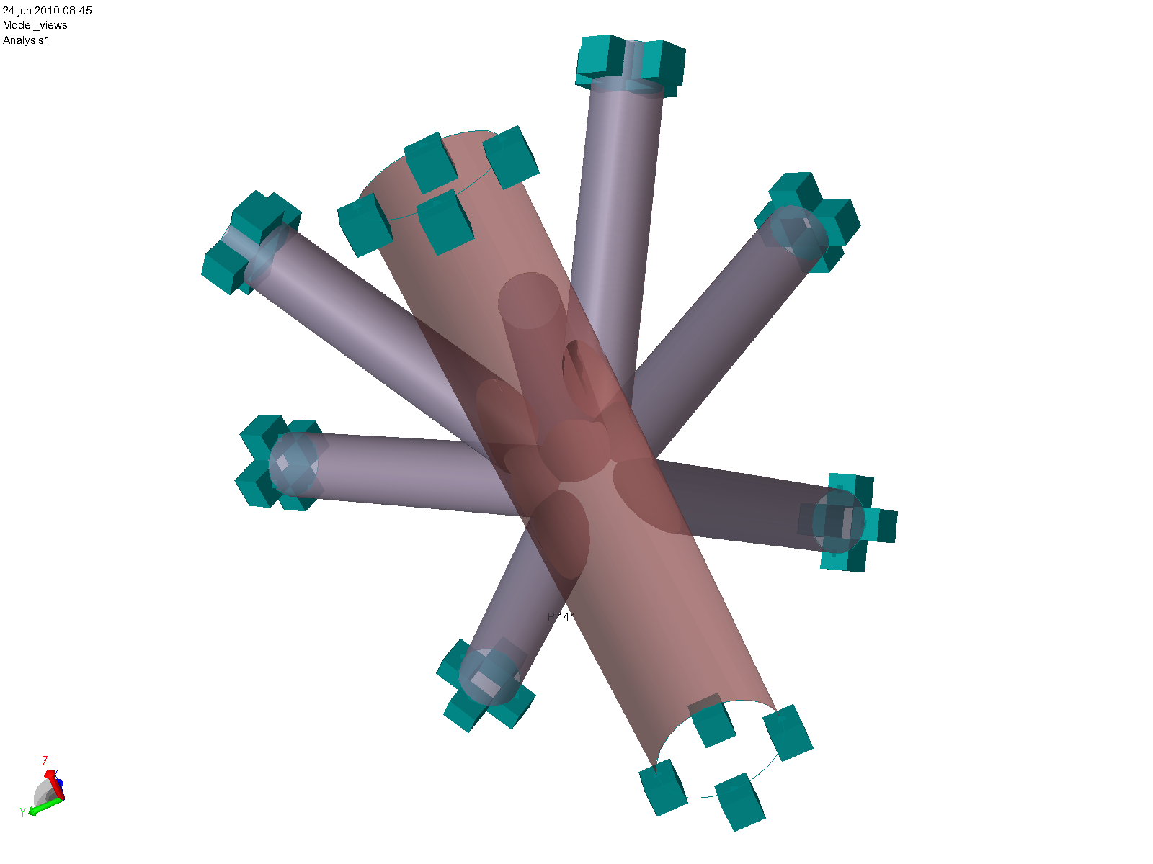

ModelView3_Modelling - Transparent.png : ModelView3_Modelling - Transparent

1.1.3.3 ModelView3_Mesh - View

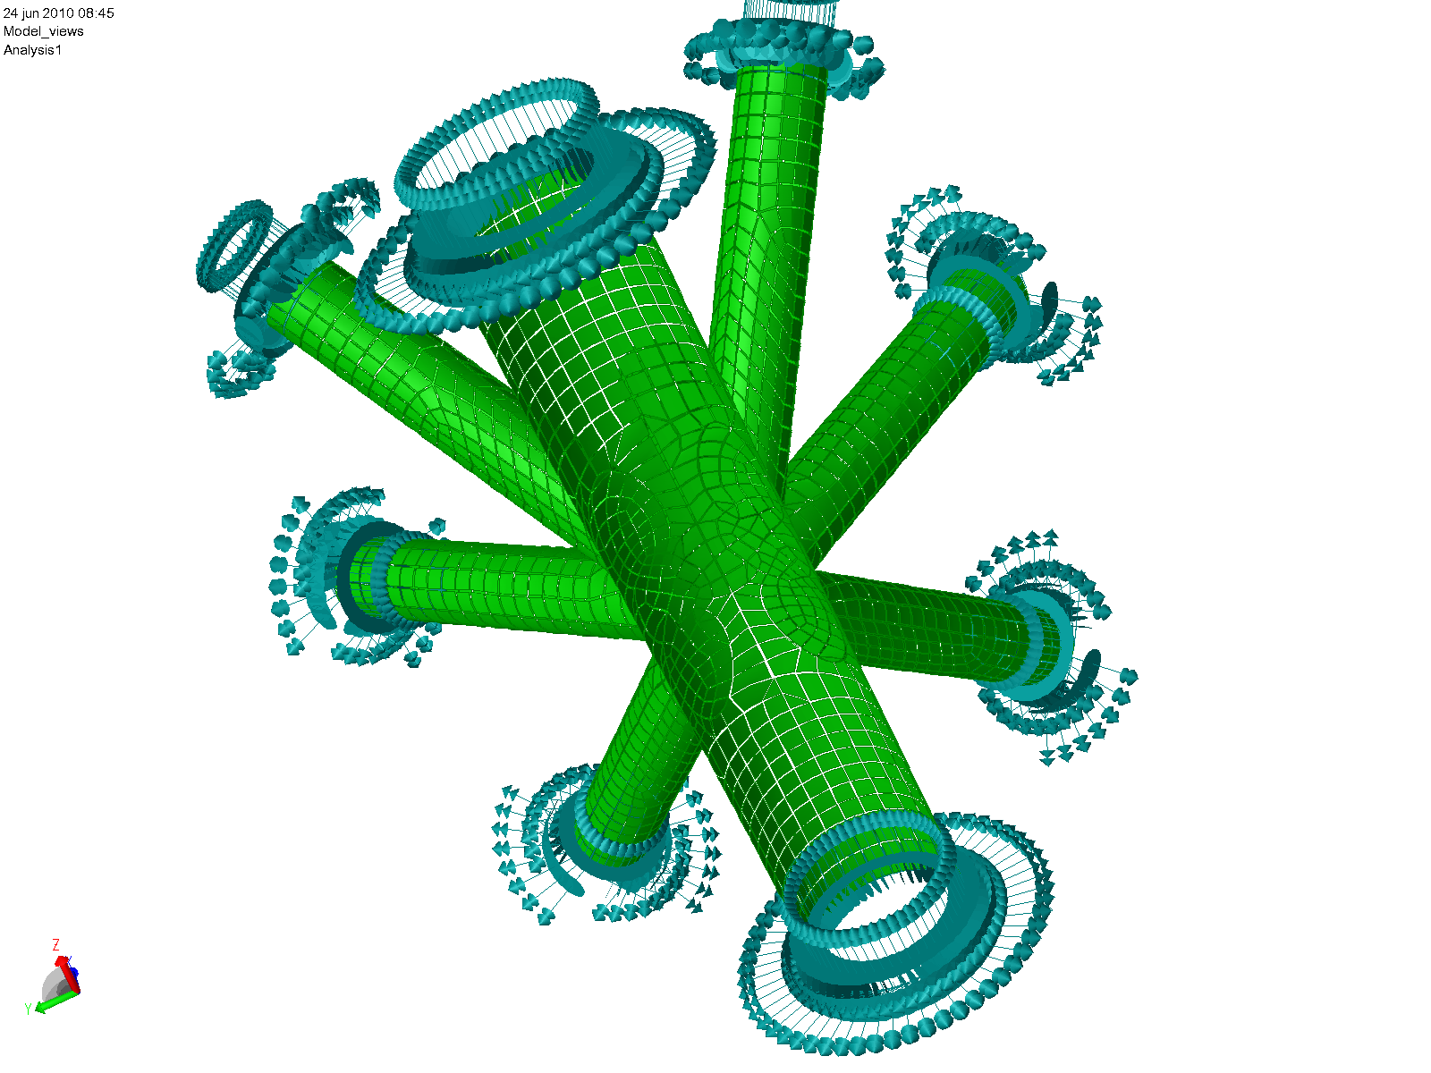

ModelView3_Mesh - View.png : ModelView3_Mesh - View

1.1.4 ModelView4

1.1.4.1 ModelView4_Modelling - All

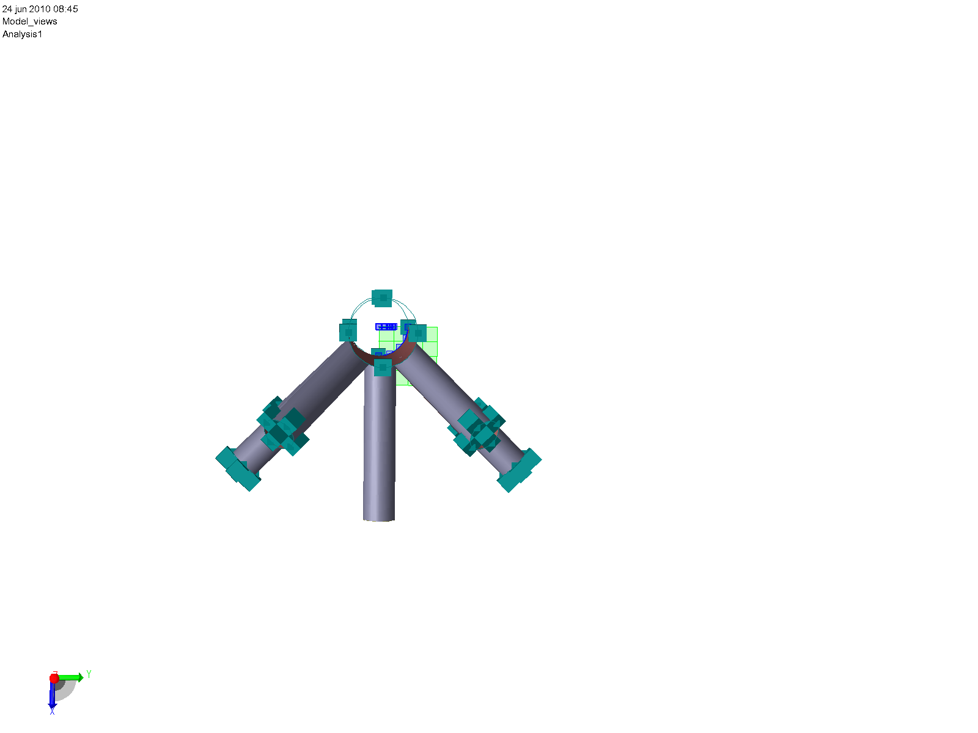

ModelView4_Modelling - All.png : ModelView4_Modelling - All

1.1.4.2 ModelView4_Modelling - Transparent

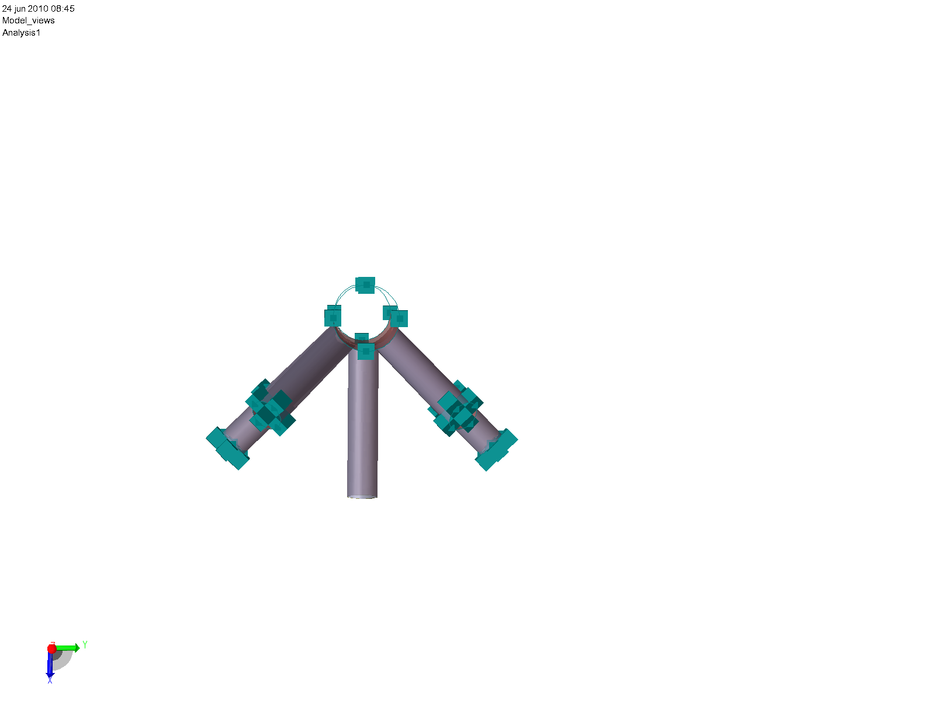

ModelView4_Modelling - Transparent.png : ModelView4_Modelling - Transparent

1.1.4.3 ModelView4_Mesh - View

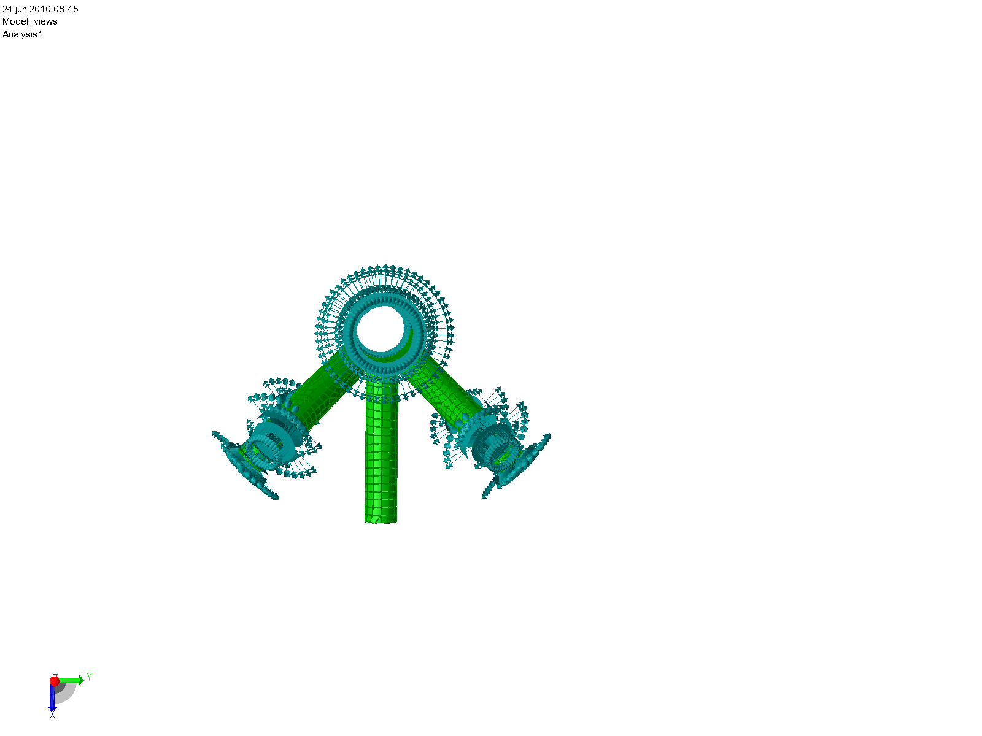

ModelView4_Mesh - View.png : ModelView4_Mesh - View

